Mathematics Methods – ATAR Year 11

Test 1 – Unit 1

Chapters 1, 2 and 8
Assessment type: Response

Conditions:

Time for the task: 55 minutes, in-class, under test conditions

Materials required:
Section One: Calculator-free Standard writing equipment
Section Two: Calculator-assumed Calculator (to be provided by the student)
Other materials allowed: Drawing templates, 1 page of notes in Section Two
Marks available: 50 marks
Section One: Calculator-free (18 marks)
Section Two: Calculator-assumed (32 marks)
Task weighting: %

Section One: Calculator-free (18 marks)
Suggested time: 20 minutes
Question 1 (4 marks)

Use the unit circle shown below to determine each of the following, giving your answers in terms of either a, b, c or d.
39⁰
1
23⁰
Q (c, d)
P (a, b)
- $\sin{23°}$

- $\cos{51°}$

- $\cos{157°}$
1

- $\sin{129°}$

Question 2 (3 marks)

- Solve $\sin{x}=-\frac{1}{2}$ for $0≤x≤360°$ (1 mark)

- Use angle sum or angle difference to show that the exact value of $\sin\left(\frac{7π}{12}\right)$ is $\frac{\sqrt{2}(\sqrt{3}+1)}{4}$ (2 marks)

Question 3 (7 marks)
- The graph of the trigonometric function $y=f(x)$ is shown.
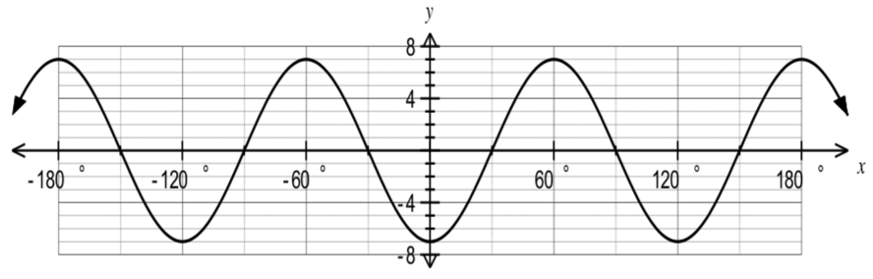
- State the amplitude of $f(x)$. (1 mark)

- State the period of $f(x)$. (1 mark)

- State the equation of the trigonometric function $f(x)$. (2 marks)

- On the axes below, sketch the graph of for $0≤x≤π.$ (3 marks)
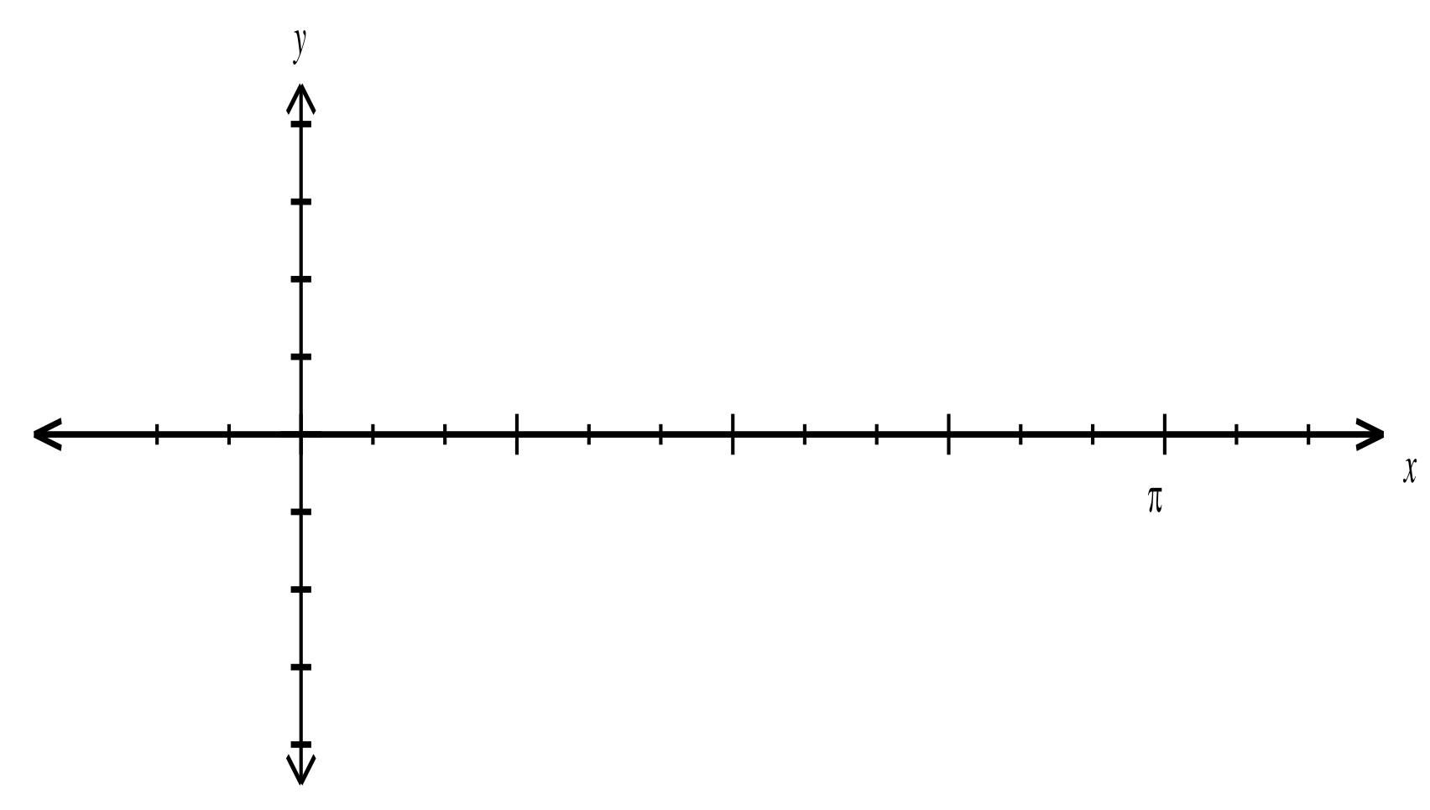
$$π$$

Question 4 (4 marks)
For the line
- Sketch the line (2 marks)

- Mark the angle of inclination the line makes with the $x$-axis.
Determine this angle. Justify your answer. (2 marks)

Section Two: Calculator-assumed (32 marks)
Suggested time: 35 minutes
Question 5 (6 marks)
- Calculate the smallest possible length of AB in the triangle shown below. (3 marks)
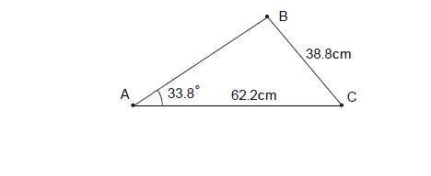
(The triangle is not drawn to scale).

- In the diagram below (not to scale), the line AC intersects the line BD at O. The angle AOB=35º, and the lengths OB=14cm, OD=26cm and AC=30cm. If the area of triangle ODC is twice that of triangle OAB, determine the length OA. (3 marks)
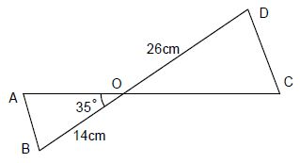

Question 6 (9 marks)
Two circles, one of radius 8cm and the other of radius 18cm, with a common tangent, touch each other as shown in the diagram.
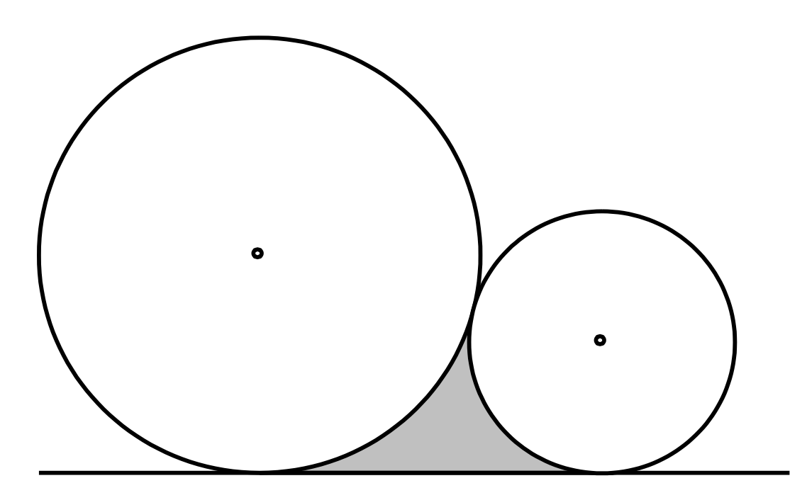
- Calculate the perimeter of the shaded region. (5 marks)

- Calculate the area of the shaded region. (4 marks)

Question 7 (6 marks)
- A and B are acute angles such that $\sin{A=\frac{3}{5}}$ and $\cos{B=\frac{12}{13}.}$
- Determine the exact values of $\cos{A}$ and $\sin{B}$. (2 marks)

- Show that the exact value of $\cos{(A+B)}$ is $\frac{33}{65}$. (2 marks)

- A and B are obtuse angle such that $\sin{A=\frac{3}{5}}$ and $\cos{B=\frac{12}{13}}$. Determine the exact value of $cos({A-B)}$. (2 marks)

Question 8 (5 marks)
- Simplify $\sin\left(A+B\right)-\sin{(A-B)}$. (1 mark)

- Solve
- $2\sin{{}_{}^{2}x-1=0, 0≤x≤2π}$. (2 marks)

- $2\cos{{}_{}^{2}{3x+\cos{3x=0, -90<x<90}}}$. (2 marks)

Question 9 (6 marks)
- Use the angle sum and difference identities to show that
- $\cos\left(2A\right)=\cos{{}_{}^{2}{A-\sin{{}_{}^{2}A}}}$. (1 mark)

- $\sin{A=\cos{(90°-A)}}$. (1 mark)

- The exact values of the sine and cosine of $36°$ are $\frac{\sqrt{10-2\sqrt{5}}}{4}$ and $\frac{1+\sqrt{5}}{4}$ respectively.
Use both identities from (a) to show that the exact value of the sine of $18°$ is $\frac{\sqrt{5}-1}{4}$. (4 marks)

